Pharmacology I · Exam 1 — Study Guide
Editable Word copy of the PA_Quizzes study aid. Headings use real Word styles, so the navigation pane and the contents field below both work, and restyling one heading restyles them all.
[In Word: right-click here and choose Update Field to build the contents.]

1 · Antibiotics, Antivirals and Antifungals
Adam Wood, Pharm.D., DABAT
INSTRUCTIONAL OBJECTIVES
- Discuss the basics of antimicrobial management, including the categorizations of drugs known as antiseptics, antimicrobials, anti-infectives, antibacterials (antibiotics), antivirals, and antifungals
- Compare and contrast the common modes of action of antimicrobial agents against microorganisms
- Explain the difference between a bacteriostatic drug and a bactericidal drug.
- Identify common drugs, indications, contraindications, molecular mechanisms of action, routes of administration, dosing protocols, potential interactions, precautions, common adverse effects, any needed laboratory monitoring, and appropriate patient education for the following classes of antibiotics: a. Penicillins b. Cephalosporins c. Monobactams d. Carbapenems e. Macrolides/ketolides f. Lincosamides g. Streptogramins h. Tetracyclines i. Aminoglycosides j. Glycopeptides & lipopeptides k. Fluoroquinolones l. Oxazolidinones m. Polypeptides n. Folate synthesis inhibitors o. Nitroimidazoles
- Identify common drugs, indications, contraindications, mechanisms of action, routes of administration, dosing protocols, potential interactions, precautions, common adverse effects, any needed laboratory monitoring, and appropriate patient education for the following classes of antivirals:
- Anti-herpes agents
- Anti-cytomegalovirus agents
- Anti-influenza agents
- Identify common drugs, indications, contraindications, mechanisms of action, routes of administration, dosing protocols, potential interactions, precautions, common adverse effects, any needed laboratory monitoring, and appropriate patient education for the following classes of antifungals: a. Echinocandins b. Polyenes c. Azoles d. Allylamines e. Mitotic inhibitors

NOTE
Two things about that list before you use it. The numbering above is reproduced exactly as the syllabus prints it. Objective 5 introduces the antivirals and then the three classes appear as top-level items 6, 7 and 8 rather than 5a to 5c — so nine printed numbers are really six objectives, and the antivirals are one objective with three parts, not four separate ones. Do not let the miscount make the antivirals look like half the lecture.
Second: Dr. Wood told the class there is no need to memorise or know drug dosages. The deck is full of regimens and this guide reproduces almost none of them. Where a number does appear it is because it is a monitoring target or a treatment duration you would counsel a patient about, not a dose.

★ PROFESSOR EMPHASIS
★ Professor emphasized
Dr. Wood told the class what his own emphasis marker is. From the Lecture 1 recording: “anytime I say… this is really notable, that’s something you should probably be starring — think about those kinds of things and write test questions.” He used that marker about fifty times. He also gave three standing rules outright:
- QT prolongation — “anytime we see QT prolongation, you should star that, underline it.” Said twice. It spans classes: macrolides, fluoroquinolones and posaconazole.
- Methicillin-resistant Staphylococcus aureus coverage — “anytime you see MRSA coverage, star it, highlight it, underline it.”
- Teratogenic drugs — “anytime we see a teratogenic drug, also note that, because it can be very significant.”
He also gave a test-question pattern outright: pneumonia in a patient from a hotel with a contaminated air-conditioning unit is always Legionella.

1.1 · Objective 1 — Categorizations of antimicrobial drugs
The lecture opens by separating terms that get used interchangeably in conversation and are not interchangeable at all.
Term | What it means
Antimicrobial | The broad category — any agent acting against a microbe
Antibacterial (antibiotic) | Acting against bacteria. Strictly, an antibiotic is of microbial origin
Antiviral | Acting against viruses
Antifungal | Acting against fungi
Antiseptic | Applied to living tissue to reduce microbial load
Anti-infective | Umbrella term covering agents used to treat infection

Choosing a regimen is then framed by drug factors: spectrum of activity; pharmacokinetics (absorption, distribution, penetration into body compartments, elimination); pharmacodynamics (bactericidal or bacteriostatic, time-dependent or concentration-dependent killing); and toxicities across six systems — gastrointestinal, integument, hematologic, central nervous system, hepatic and renal. Those six recur as the monitoring parameters for individual classes later, so they are worth reading as a checklist rather than a list.
The lecturer's own framing is worth keeping: this class is not the end of pharmacology, and the real-world answer is to use references — guidelines, textbooks, online references and a friendly pharmacist. Art versus science; things are rarely black and white.

1.2 · Objective 2 — Common modes of action
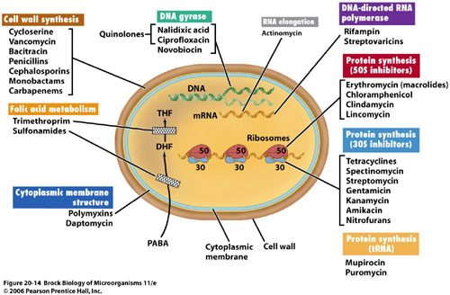
The single most useful figure in the antibacterial half, because it answers objective 2 in one picture. Every class in this lecture is somewhere on this cell. Read it as a map: the cell wall agents sit on the outside, the two ribosomal groups sit in the middle with 50S and 30S separated, and folate metabolism sits below as a supply line rather than a structure. Holding this image is worth more than holding fifteen separate mechanisms, because it tells you what a drug does from where it acts. Figure 20-14, Brock Biology of Microorganisms 11th edition, © 2006 Pearson Prentice Hall. Reproduced from the lecture slides (Slide 11).
Target | Classes
Cell wall synthesis | Penicillins, cephalosporins, monobactams, carbapenems, vancomycin, bacitracin
Protein synthesis — 50S subunit | Macrolides, clindamycin, chloramphenicol, streptogramins
Protein synthesis — 30S subunit | Aminoglycosides, tetracyclines
DNA gyrase / topoisomerase | Fluoroquinolones
Folic acid metabolism | Sulfonamides, trimethoprim
Cytoplasmic membrane | Polymyxins, daptomycin
Nucleic acid, direct damage | Metronidazole

NOTE
Why the ribosome is a target at all. The bacterial ribosome is 70S, made of a 50S and a 30S subunit; the mammalian one is 80S, made of 60S and 40S. That difference is the entire basis of selectivity — and it is a difference of degree, not an absolute barrier, which is why high levels of these drugs can interact with mammalian ribosomes and produce dose-related toxicity.

1.3 · Objective 3 — Bacteriostatic versus bactericidal
Bacteriostatic inhibits a vital pathway used in bacterial growth but does not directly cause death. Bactericidal disrupts function enough that death occurs. The lecture gives five and six agents respectively:
Bacteriostatic | Bactericidal
Erythromycin · tetracyclines · sulfonamides · trimethoprim · clindamycin | Penicillins · cephalosporins · aminoglycosides · vancomycin · fluoroquinolones · metronidazole

Notice the bactericidal list spans the cell wall, the ribosome and DNA. Killing is not tied to one target, so you cannot infer static-versus-cidal from mechanism alone — it has to be learned.
 | Concentration-dependent | Time-dependent
What drives killing | Higher concentration, greater killing | Time above the minimal inhibitory concentration
Post-antibiotic effect | Present | None
Target | Peak level | 40–70% of the dosing interval above the minimal inhibitory concentration
Dosing that follows | Large, widely spaced doses | Continuous or frequent infusions

This is the reasoning behind two things you will see on the wards: the aminoglycosides moving from every 8 hours to once daily, and piperacillin/tazobactam being given as an extended infusion. One exploits a post-antibiotic effect; the other buys time above the minimal inhibitory concentration.

1.4 · Objective 4 — Beta-lactams
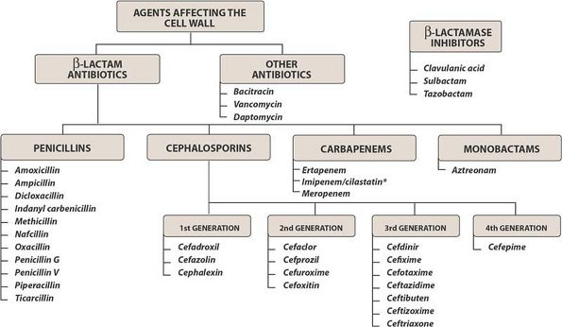
Class before agent, drawn out. The top split is the one that matters: beta-lactams on one side, and bacitracin, vancomycin and daptomycin on the other as cell wall agents that are not beta-lactams. Notice that the beta-lactamase inhibitors sit in their own box off to the side, which is exactly right — they have no antibacterial activity of their own and only exist to protect a partner drug. The cephalosporin generations run left to right, and the agents beneath each are worth reading as examples of a generation rather than as a list to memorise. Reproduced from the lecture slides (Slide 12).

Penicillins (objective 4a)
The beta-lactam ring mimics two D-alanine residues. The cross-linking enzyme — a penicillin-binding protein — binds the drug by mistake and is covalently inactivated. Once enough penicillin-binding protein is inactive, peptidoglycan chains are still synthesized but no new cross-links can form.
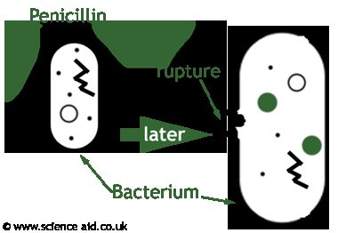
What the mechanism actually produces. Penicillin does not poison the cell directly — it inactivates the enzyme that cross-links peptidoglycan, so the wall keeps being built and never gets tied together. The cell then fails mechanically, which is why the effect is bactericidal and why it is strongest in organisms that are actively dividing. © www.scienceaid.co.uk. Reproduced from the lecture slides (Slide 16).
Subclass | Agents | What it is for
Natural | Penicillin G, penicillin V potassium, penicillin G benzathine | Syphilis, gas gangrene, meningococcus. Good Gram-positive cocci, no Staphylococcus, no aerobic Gram-negatives
Aminopenicillins | Ampicillin, amoxicillin | Enterococcus, Listeria, endocarditis prophylaxis, upper respiratory infection, community-acquired pneumonia at high dose
With a beta-lactamase inhibitor | Augmentin, Unasyn, Zosyn | Adds Bacteroides and methicillin-susceptible Staphylococcus aureus. Skin and soft tissue, diabetic foot, animal and human bites
Penicillinase-resistant | Nafcillin, oxacillin, dicloxacillin | Built solely for methicillin-susceptible Staphylococcus aureus; increasingly defeated by methicillin resistance
Antipseudomonal | Piperacillin, piperacillin/tazobactam | Polymicrobial and nosocomial infection, intra-abdominal infection, Pseudomonas

Dosage forms are worth separating from doses. Penicillin V potassium is the oral form because it is stable in stomach acid; penicillin G is intravenous; penicillin G benzathine is the long-acting intramuscular depot given as a one-time dose.
Resistance is beta-lactamase cleaving the beta-lactam ring. The inhibitors — sulbactam with ampicillin, tazobactam with piperacillin, clavulanate with amoxicillin — have no antibacterial activity of their own and irreversibly inactivate the enzyme.
NOTE
Adverse effects and interactions worth holding. Aminopenicillins: hepatic dysfunction, Clostridium difficile, Stevens-Johnson syndrome and toxic epidermal necrolysis, interstitial nephritis, anemia and thrombocytopenia. Interactions: prolongation of the prothrombin time with anticoagulants, and reduced oral contraceptive effectiveness — the lecture is candid that the evidence for the latter is not strong, the proposed mechanism being disrupted gut flora and reduced enterohepatic recycling of estrogens. Advise backup contraception anyway.

Cephalosporins (objective 4b)
Good cerebrospinal fluid penetration, mostly renal elimination, and penicillin cross-sensitivity of less than 1% — lower than the figure usually quoted, and clinically important because a reported penicillin allergy does not by itself rule a cephalosporin out.
Generation | Agents | Coverage
1st | Cefazolin, cephalexin | Great Gram-positive (no Enterococcus), some Gram-negative. Surgical prophylaxis, cellulitis, urinary tract infection
2nd | Cefotetan, cefoxitin, cefuroxime, cefprozil | More Gram-negative — Haemophilus, Neisseria, Proteus, Escherichia coli, Klebsiella
3rd | Ceftriaxone, ceftazidime, cefotaxime, cefdinir, cefixime | Better Gram-negative, less Gram-positive. Ceftazidime adds Pseudomonas
4th | Cefepime | Gram-negative and retained Gram-positive, antipseudomonal. No methicillin-resistant Staphylococcus aureus, no Enterococcus, no anaerobes
5th | Ceftaroline; ceftolozane/tazobactam | Ceftaroline is the one with methicillin-resistant coverage. Ceftolozane is the antipseudomonal one

The generation rule and its exception: moving up the generations buys Gram-negative activity and costs Gram-positive activity — except the 4th generation, which gains Gram-negative without sacrificing Gram-positive. That single exception is what makes cefepime broad rather than merely Gram-negative, and it is why cefepime is the drug of choice for neutropenic fever.
Two agent-specific points that are easy to confuse and easy to test: ceftriaxone needs no dosage adjustment in renal insufficiency but cannot be used in the first 30 days of life, and cefotaxime is the one preferred in neonatal fever or sepsis.

Monobactams (objective 4c) and carbapenems (objective 4d)
Aztreonam covers Gram-negatives only — a spectrum the lecture describes as resembling the aminoglycosides, including Pseudomonas aeruginosa and Enterobacteriaceae, with no Gram-positive or anaerobic activity. Its defining property is that it has no cross-reactivity with other beta-lactams, so it can be used in truly penicillin-allergic patients.
Carbapenems — imipenem, meropenem, ertapenem, doripenem — are very broad: Gram-positive (not methicillin-resistant Staphylococcus aureus), Gram-negative, Pseudomonas (except ertapenem), and anaerobes. They resist hydrolysis by beta-lactamases, which is why they are the answer for extended-spectrum beta-lactamase producers, multidrug-resistant Gram-negatives, nosocomial infection and meningitis. Watch for seizures with imipenem.

1.5 · Objective 4 — Glycopeptides & lipopeptides (objective 4j)
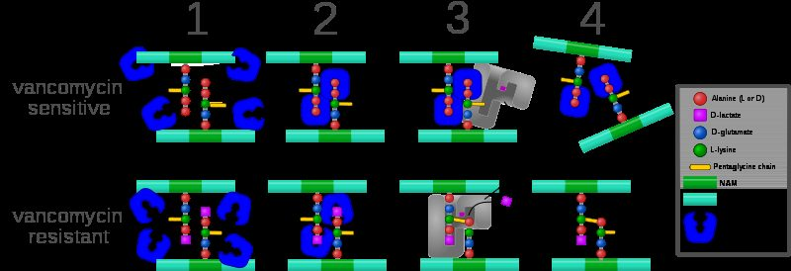
Mechanism and resistance in the same picture. In the top row vancomycin caps the two terminal D-alanine residues, so the cross-linking enzyme cannot reach its substrate. In the bottom row a single substitution — D-lactate in place of the terminal D-alanine — means vancomycin no longer binds, and cross-linking proceeds normally. That one change is the whole basis of vancomycin resistance, and it explains why the lecture says resistance is harder to develop here than against penicillin: the drug covers the substrate rather than disabling an enzyme, so the organism has to rebuild its own building block. Reproduced from the lecture slides (Slide 46).
Vancomycin is not a beta-lactam. It also targets the cell wall, but it binds the two D-alanine residues on the peptide to block cross-linking rather than inactivating the enzyme — and because it covers the substrate rather than disabling an enzyme, resistance is harder to develop.
Coverage is Gram-positive only. Drug of choice for penicillin-allergy infections, methicillin-resistant Staphylococcus aureus, Clostridium difficile by mouth, endocarditis, osteomyelitis, and surgical prophylaxis in allergy.
NOTE
Monitoring is the examinable part. Vancomycin requires therapeutic drug monitoring. Troughs are drawn 15 to 30 minutes before the next scheduled dose, usually around the third or fourth dose — that timing is what makes the level reflect steady state. Random levels are used in unstable or severe renal impairment, and the time of the draw must be specified. Watch renal clearance, ototoxicity and nephrotoxicity, and the infusion-related reactions: red man syndrome, fever, chills and phlebitis.

Where the minimal inhibitory concentration is 2 mg/L or greater, the target ratio of area under the curve to minimal inhibitory concentration becomes difficult to achieve and alternative therapy such as linezolid may be needed — pushing the dose is not a reliable answer.
Daptomycin causes bacterial depolarization, inhibiting DNA, RNA and protein synthesis, and is bactericidal. Its one crucial limitation: it cannot be used in pneumonia. Monitor muscle pain and creatine phosphokinase.

1.6 · Objective 4 — Protein synthesis inhibitors
Class | Subunit & mechanism | Key points
Macrolides (4e)  erythromycin, clarithromycin, azithromycin | 50S; blocks transpeptidation | Gram-positive aerobes and atypicals — Legionella, Mycoplasma, Chlamydophila, Chlamydia. QT prolongation and torsades de pointes. Cytochrome P450 3A inhibition, erythromycin > clarithromycin > azithromycin
Lincosamides (4f)  clindamycin | 50S | Gram-positive aerobes including methicillin-resistant Staphylococcus aureus, plus Gram-positive and Gram-negative anaerobes. No Gram-negative aerobic coverage. Toxin-mediated disease. Clostridium difficile and pseudomembranous colitis
Tetracyclines (4h)  tetracycline, doxycycline, minocycline | 30S; binds 16S ribosomal RNA, blocks transfer RNA at the A site. Bacteriostatic | Excellent for atypicals and animal-borne organisms. Chelate cations — iron and calcium. Photosensitivity, tooth discoloration, avoid under 8 years and in the 2nd and 3rd trimesters
Aminoglycosides (4i)  gentamicin, tobramycin, amikacin | 30S | Gram-negatives including Pseudomonas; Enterococcus at synergy dosing only. Post-antibiotic effect → once-daily dosing. Nephrotoxic and ototoxic
Oxazolidinones (4l)  linezolid | 50S | Resistant Gram-positives — multidrug-resistant pneumococcus, methicillin-resistant Staphylococcus aureus, vancomycin-resistant Enterococcus. No Gram-negatives or anaerobes. Thrombocytopenia; serotonin syndrome with selective serotonin reuptake inhibitors, tyramine foods, pseudoephedrine
Streptogramins (4g) | 50S | Named in the syllabus and on the mechanism slide; the deck gives no dedicated agent slides

Tigecycline, a glycylcycline, binds the 30S subunit and is bacteriostatic. It is approved for complicated skin and complicated intra-abdominal infection, covering methicillin-resistant Staphylococcus aureus and Enterococcus faecalisbut not vancomycin-resistant Enterococcus.

1.7 · Objective 4 — DNA, folate and membrane agents
Class | Mechanism | Key points
Fluoroquinolones (4k)  ciprofloxacin, levofloxacin, moxifloxacin | Dual — inhibits DNA gyrase (topoisomerase II) forming a quinolone-DNA-gyrase complex with induced DNA cleavage, and inhibits topoisomerase IV | Levofloxacin has Pseudomonas coverage; moxifloxacin does not and must not be used for urinary tract infection. Chelated by iron, antacids, multivitamins, calcium and dairy. QT prolongation. Tendonitis and Achilles rupture, peripheral neuropathy, central nervous system toxicity; caution under 18. Overuse drives resistance, with Clostridium difficile as collateral damage
Folate synthesis inhibitors (4n)  sulfamethoxazole/trimethoprim | Two sequential steps: sulfamethoxazole blocks para-aminobenzoic acid → dihydrofolic acid via tetrahydropteroic acid synthetase; trimethoprim blocks dihydrofolic acid → tetrahydrofolic acid via dihydrofolate reductase | Covers methicillin-resistant Staphylococcus aureus, not enterococci. Pneumocystis jirovecii treatment and prophylaxis, urinary tract infection, prostatitis. Stevens-Johnson syndrome and toxic epidermal necrolysis, blood dyscrasias. Raises the international normalised ratio significantly with warfarin via cytochrome P450 2C9 inhibition
Nitroimidazoles (4o)  metronidazole | Interacts with bacterial DNA causing loss of helical structure and strand breakage | Gram-positive and Gram-negative anaerobes and parasites. Drug of choice for Clostridium difficile, intra-abdominal combination therapy, sexually transmitted infections. Disulfiram-like reaction with ethanol
Polypeptides (4m)  polymyxin B, polymyxin E | Detergent-like interaction with the lipopolysaccharide of the Gram-negative outer membrane, displacing magnesium and calcium | Broad Gram-negative coverage. Resistance uncommon because the class went largely unused for 50 years, and use is expected to rise with multidrug resistance

★ PROFESSOR EMPHASIS
★ Black box warnings
The polymyxins carry the only warnings this deck labels explicitly as black box: nephrotoxicity, neurotoxicity and neuromuscular blockade. Black box warnings rank third in what to weight for this exam — above ordinary adverse effects — so they are worth holding separately rather than folding into a general side-effect list.

1.8 · Objectives 5–8 — Antivirals
Eight general approaches are listed: block attachment, block uncoating, inhibit DNA or RNA synthesis, inhibit viral protein synthesis, inhibit specific viral enzymes, inhibit assembly, inhibit release, and stimulate the host immune system. Every agent below is one of those.
Virus | What it causes
Herpes simplex type 1 | Mouth, face, skin, esophagus or brain
Herpes simplex type 2 | Genitals, rectum, hands or meninges
Varicella-zoster | Chickenpox and shingles
Cytomegalovirus | Retinitis, esophagitis, colitis

Agents | Mechanism | Used for
Acyclovir, valacyclovir (obj. 6) | Guanine analog lacking the sugar moiety; selectively phosphorylated by viral thymidine kinase, incorporated into viral DNA, and the missing sugar prevents elongation | Herpes simplex, varicella-zoster. Valacyclovir is the prodrug with far better oral absorption
Penciclovir, famciclovir (obj. 6) | Similar to acyclovir | Herpes simplex and varicella-zoster. Famciclovir is the oral prodrug; penciclovir is intravenous
Ganciclovir, valganciclovir (obj. 7) | Guanine analog, inhibiting similarly to acyclovir | Cytomegalovirus in transplant and immunocompromised patients. Valganciclovir is the better-absorbed oral prodrug
Oseltamivir (obj. 8) | Prodrug converted to its carboxylate form; inhibits neuraminidase so budding progeny cannot be cleaved free of the host cell | Influenza A and B. Oral only, renally adjusted

NOTE
Selectivity, two different ways. Acyclovir is switched on by a viral enzyme — it is only phosphorylated where the virus is replicating. Oseltamivir switches a viral enzyme off. Both act on the virus and not the host, by opposite routes.

Timing matters and is examinable. Oseltamivir must be started as soon as possible, within 48 hours; because it blocks release of new virus rather than clearing virus already present, late treatment has little to act on. Acyclovir given in the first 24 hours of chickenpox shortens the acute illness but does not cure the infection.
Adverse effects. Acyclovir: nausea, vomiting, rash, bone marrow suppression, central nervous system effects (seizures, delirium, tremor), and crystallisation in the renal tubule — maintain hydration and renal function. Ganciclovir is the harder drug: neutropenia and thrombocytopenia, central nervous system effects including confusion, ataxia, seizures and coma, and about a third of patients must stop intravenous treatment because of side effects.
Four prodrugs appear in this short section — valacyclovir, famciclovir, valganciclovir and oseltamivir. Each exists to solve poor oral absorption of its parent. If a question asks why one agent is preferred orally, the prodrug design is usually the answer.

1.9 · Objective 9 — Antifungals
Fungi are eukaryotic, with a rigid cell wall containing chitin, a cell membrane built on ergosterol, different ribosomes and a distinct nuclear membrane. They are resistant to antibiotics, and every antifungal class exploits one of those differences.
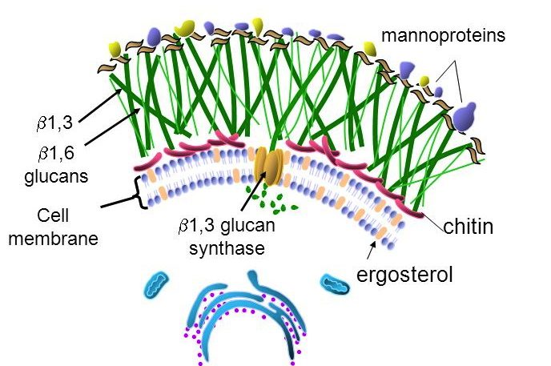
Both antifungal targets on one image, which is why this figure carries the whole of objective 9. The green mesh is glucan, and the orange enzyme spanning the membrane is beta-1,3 glucan synthase — the echinocandin target, and the only one here with no mammalian counterpart at all, since human cells have no cell wall. Below it, threaded through the membrane, is ergosterol: bound directly by the polyenes, and depleted upstream by the azoles and allylamines. Sort any antifungal by which of those two structures it attacks and the class list stops needing memorisation. Reproduced from the lecture slides (Slide 90).
Predisposing factors: loss of barriers (burns, surgery, catheters); immunodeficiency (cancer, human immunodeficiency virus infection, transplant, chemotherapy); metabolic abnormality (diabetes); suppression of competing organisms (antibiotics); and a warm moist environment (diaper rash, athlete's foot). Note that treating a bacterial infection is itself a fungal risk factor.
Depth | Organisms
Systemic — internal organs | Aspergillus, Blastomyces, Candida, Coccidioides, Cryptococcus, Histoplasma, Zygomycetes
Subcutaneous — skin layers | Chromomycosis, Pseudallescheriasis, Sporotrichosis
Superficial — hair, nails, mucous membranes | Epidermophyton, Microsporum, Trichophyton

Class | Target & mechanism | Agents and key points
Polyenes (9b) | Membrane — bind ergosterol already present, forming channels; oxidative damage | Amphotericin B, nystatin, natamycin. Lipid formulations cost 20–50× more with reduced toxicity. Fever and chills from interleukin-1 and tumour necrosis factor — pretreat. Hypokalaemia, hypomagnesaemia, hypotension, renal tubule damage — hydrate with normal saline. Nystatin is poorly absorbed, so topical and oral only
Azoles (9c) | Membrane — inhibit fungal cytochrome P450 14-alpha-demethylase, blocking lanosterol → ergosterol | Fluconazole: best oral absorption, penetrates the central nervous system, cryptococcal meningitis and candidiasis. Voriconazole: systemic aspergillosis, vision effects in ~30%, cyclodextrin vehicle accumulates in renal failure. Posaconazole: the only azole effective against the Zygomycetes, QT prolongation. Itraconazole: blastomycosis, histoplasmosis, onychomycosis. Ketoconazole: rarely used — no central nervous system entry, strong cytochrome P450 3A4 inhibition
Echinocandins (9a) | Cell wall — inhibit 1,3-beta-D-glucan synthase | Caspofungin, micafungin, anidulafungin. Oesophageal candidiasis, refractory aspergillosis, febrile neutropenia. Tachycardia, headache, insomnia, hypokalaemia, hypomagnesaemia
Allylamines (9d) | Membrane — inhibit squalene epoxidase | Naftifine (topical), terbinafine (oral and topical). Superficial dermatophytes. Fingernails 6–12 weeks, toenails up to 12 months
Mitotic inhibitors (9e) | Cell division — interrupts mitotic spindles | Griseofulvin, from Penicillium griseofulvum. Deposited in keratin precursor cells. Scalp ~1 month, fingernails 6–9 months, toenails up to 12 months. Absorption increased by a high-fat meal. Not effective against Candida; fungistatic. Induces cytochrome P450 1A2 and 2C9

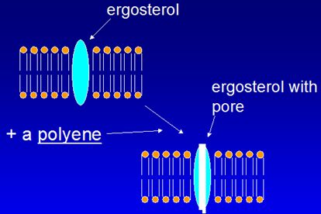
Why polyene toxicity is so predictable. The drug binds ergosterol already present and opens a channel through it, so potassium and magnesium leak out of the cell. That is a physical hole rather than an enzymatic block, which is why the effect is immediate and why the human toxicity is electrolyte disturbance — mammalian membranes contain the related sterol cholesterol, so the same trick works, just less well. Reproduced from the lecture slides (Slide 96).
Flucytosine sits outside that scheme: it is converted to 5-fluorouridine by cytosine deaminase, an enzyme human cells lack, and then inhibits thymidylate synthase. Used with amphotericin B in cryptococcal meningitis and with itraconazole in chromoblastomycosis. Bone marrow suppression, hepatotoxicity, gastrointestinal upset, rash.
Sorting the antifungals is a two-question exercise. First: wall or membrane? Echinocandins are the only wall agents. Second, for the membrane agents: bind ergosterol (polyenes) or block its synthesis (azoles at lanosterol demethylase, allylamines at squalene epoxidase)? Griseofulvin and flucytosine are the two that sit outside both questions.
The tinea names are worth knowing outright: tinea pedis athlete's foot, tinea corporis ringworm, tinea cruris jock itch, tinea unguium onychomycosis of the nails.

1.10 · Taught but not in the objectives
NOTE
Anthelmintics. Slides 114 to 116 cover the benzimidazoles — albendazole and mebendazole, which inhibit helminth microtubule formation and block glucose uptake, used for hookworm, roundworm, pinworm and whipworm — and pyrantel pamoate, which releases acetylcholine and inhibits cholinesterase, acting as a depolarizing neuromuscular blocker to paralyse the parasite, used for pinworm and hookworm.
They are included here and in the antifungal quizzes because he taught them, but they appear in no syllabus objective — objectives 4, 5 and 9 cover antibacterials, antivirals and antifungals only. Worth confirming their status before spending time on them. Tolnaftate is in a similar position: it distorts hyphae and stunts mycelial growth, treats tinea pedis, cruris and corporis but not tinea unguium, and is topical only.

